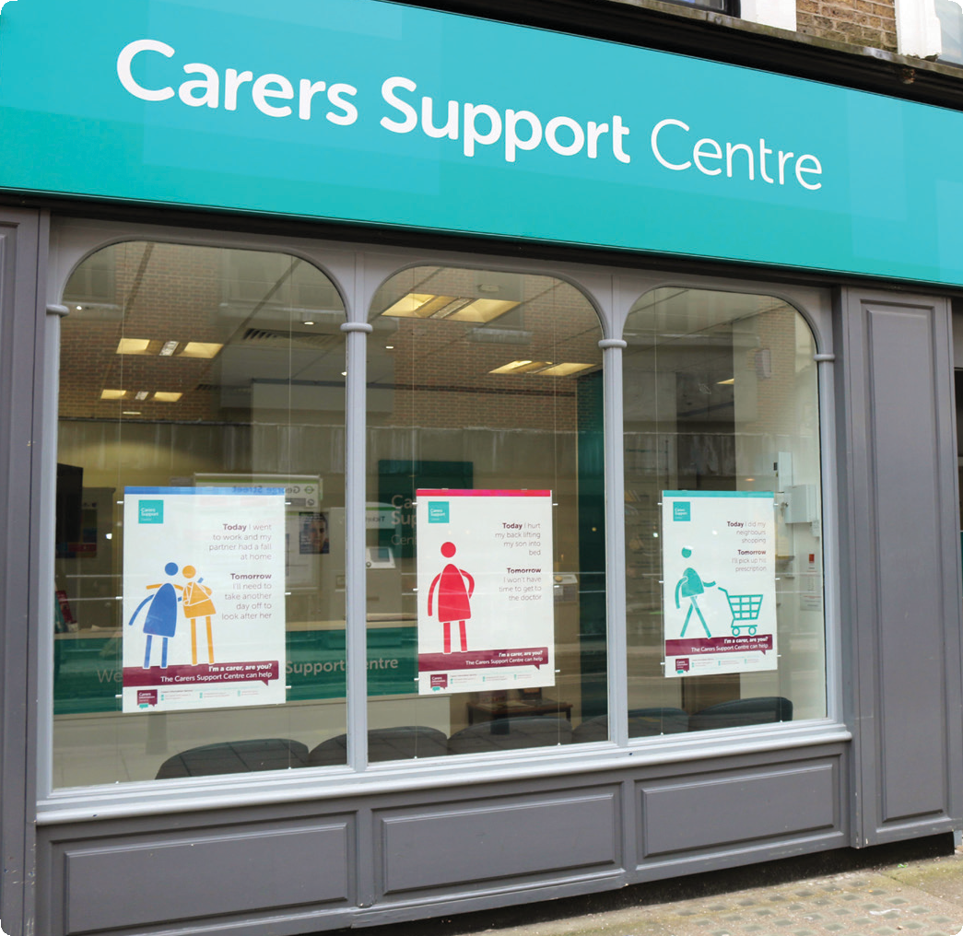We support people looking after a relative, partner, friend or neighbour in Croydon

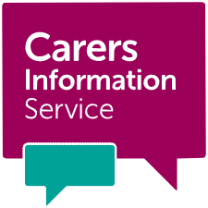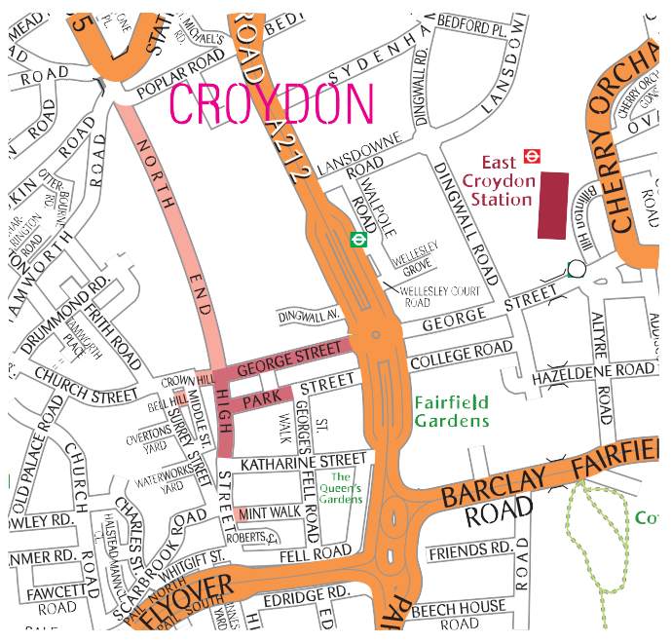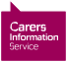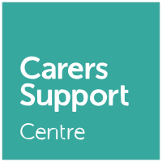Carers Support Centre
The Carers Information Service runs the Carers Support Centre, a drop-in centre for carers
in Croydon offering free information, advice, wellbeing events, workshops and support. Based in George Street in central Croydon, we’re open Monday to Friday, 10am-4pm.

The Centre is the one stop shop for carers in Croydon, and is home to a number of organisations supporting carers across the
borough. Why not drop in and see how we can help you?

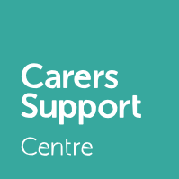Find our contact details
on the back of this leaflet.
Find us opposite George Street tram stop, a short walk from East Croydon Station. The nearest car park is NCP Croydon Central in Dingwall Avenue CR0 2AA. Disabled parking bays are available in Park Street and Fell Road.

Get in touch with us:
Visit: Carers Support Centre,
24 George Street, Croydon CR0 1PB (Monday to Friday, 10am-4pm)

Call: 020 8649 9339, option 1 Email: info@carersinfo.org.uk Website: www.carersinfo.org.uk Twitter: @informingcarers Facebook: Informing Carers

Published November 2019

Who do you care for?

Carers Information Service

Informing carers in Croydon

Am I a carer?
A carer looks after a friend, partner, family member or neighbour who needs help due to illness, disability or old age. The support carers provide is unpaid. You don’t have to provide full-
time care or receive Carer’s Allowance to be a carer.

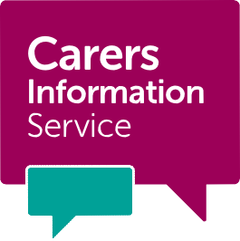About

the Carers Information Service
We provide free information, advice and support to carers in the London Borough
of Croydon. We run the Carers Support Centre, the one stop shop for carers in Croydon. We are part of the John Whitgift
Foundation and supported by Croydon Council.

What we offer carers

Advice and support
- Information and advice via drop-in service, phone, email and online.
- Carer’s Assessments for carers of adults in Croydon (020 8663 5664).
- Regular advice surgeries and workshops.

Looking after your wellbeing
- Carers Café offering free hot drinks, books and Wi-Fi. The Café is open on weekday mornings 10.30am-12.30pm at the Carers Support Centre.
- Health and wellbeing programme including massage, dance and singing.
- Range of support groups meeting at the Carers Support Centre.

Keeping you informed
- How To… A Guide for Carers in Croydon, our factsheet series on what you need to know as a carer in Croydon.
- Regular newsletter and e-bulletin with the latest events, news and information for carers.
- Online directory of local services.

Useful resources
- Free membership of the Carers Support Centre.
- Emergency Carers Cards for peace of mind.
- Radar keys for disabled toilets (currently £3).

Support for former carers
- Range of support for former and bereaved adult carers, including a bereavement support group led by a BACP registered counsellor (tanyafitzgerald@carersinfo.org.uk).

What we offer professionals
Your client is welcome to contact us directly on 020 8649 9339, option 1 or you can talk to us on your client’s behalf. With your client’s consent, we can take their details, make appropriate follow ups or referrals and send them a carers’ information pack if they would like one.

Rooms for hire
The Carers Support Centre has a choice of bright, modern rooms for hire at reasonable rates. Whether it’s an event, support group, training session or one-to-one meeting, we have a room to suit your needs.

For more information on room hire, visit www.carersinfo.org.uk/room-hire, email bookings@carersinfo.org.uk
or call 020 8663 5600.

Get in touch with us:
Visit: Carers Support Centre,
24 George Street, Croydon CR0 1PB
Call: 020 8649 9339, option 1
Email: info@carersinfo.org.uk

